**Online Benefits Payment Instructions**

1. Click [HERE](https://www.locallevelevents.com/events/details/26889) to access the online payment website.
2. Click the “Pay Here!” box

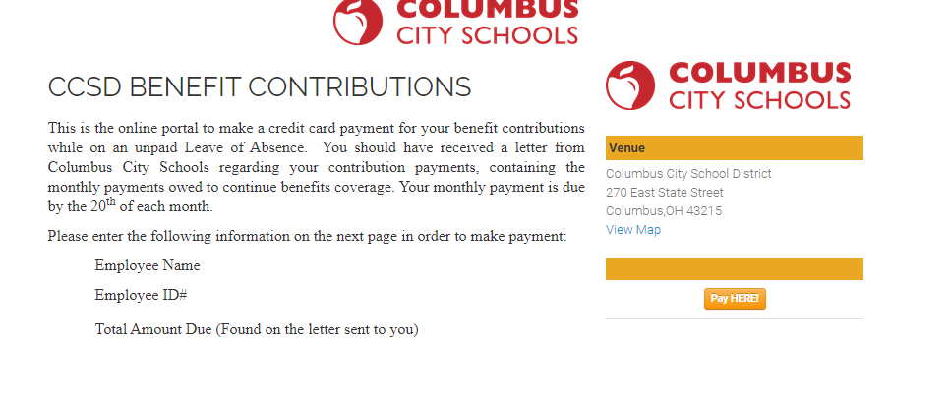

1. If you are a first time user, you will need to set up an account. Click on “Create one here.” **Make sure after you set up your account to remember your username and password for the future.**

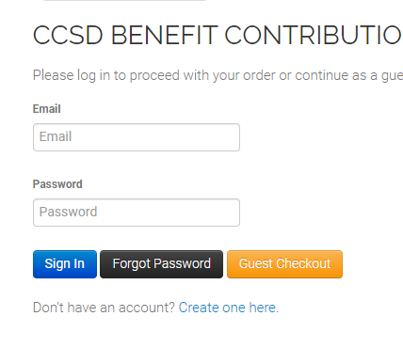

1. 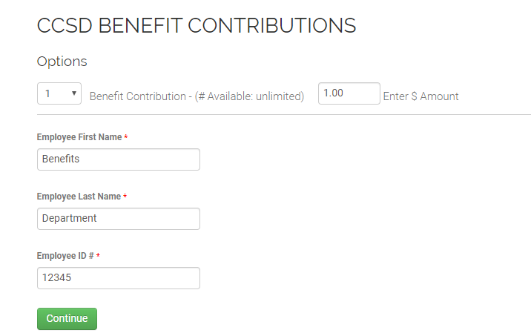Once you login, enter your payment information on the next screen. For the “Benefit Contribution” enter 1. Enter the dollar amount you are paying in the next box. The amount you owe can be found in the letter/email your received from the Benefits Department. Enter your name and your CCS employee ID. Click “Continue”
2. Double check your information is correct on the next page and then click “Continue to Payment.”

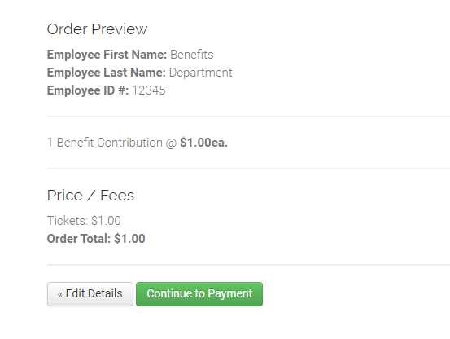

1. 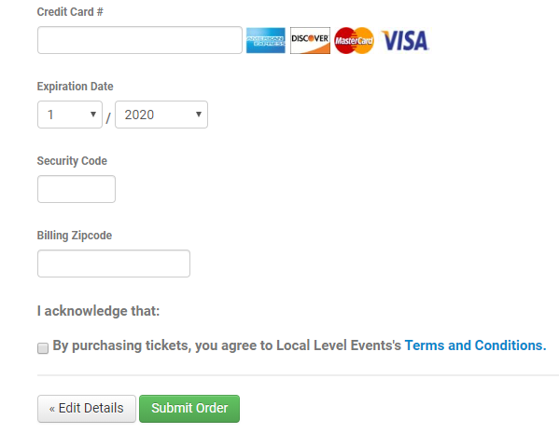On the final page, enter your credit/debit card information. You will need to check the box that says; “By purchasing tickets, you agree to Local Level Events’s Terms and Conditions.” Lastly, you must click “Submit Order.”